Tip Summary
Path : Reports >> Tip Summary.

Steps to reach Tip Summary:
Step 1 : Reports in Steps to reach Tip Summary : Open the Reports module from the Billing Application(POS).
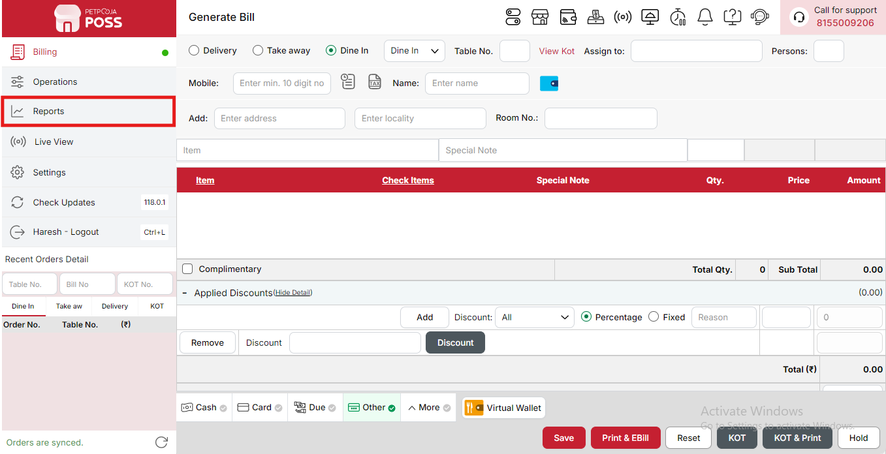
{Image Name: Reports Option,
Description: The red box highlights the “Reports” option in the sidebar menu. This section allows users to view and analyze various business reports, such as sales, billing, and order summaries, helping in effective tracking and decision-making.Here is an image of Step 1 Report in Steps to Reach Tip Summary}
Step 2 : Tip Summary in Steps to reach Tip Summary : Select Tip Summary to view a detailed record of all tips received by employees, including total tips collected and distributed during the selected period.
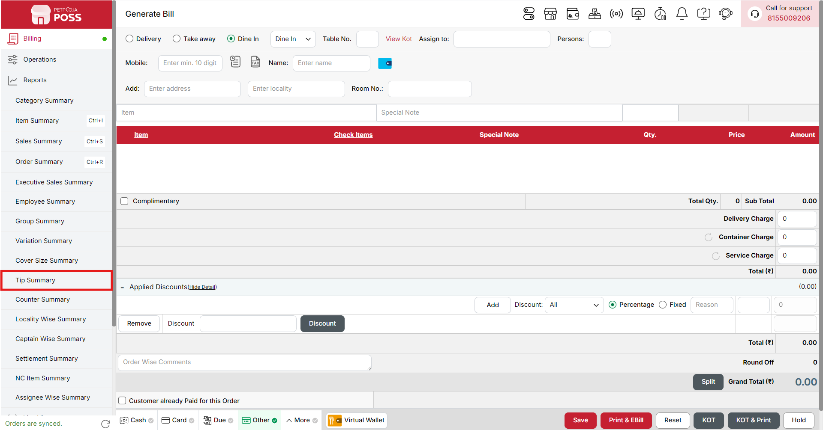
{Image Name: Tip Summary,
Description: The red box highlights the Tip Summary option under the Reports section. This feature allows users to review and analyze tips received by staff, providing a clear record of tip distribution and helping in staff performance evaluation and payout management.Here is an image of Step 2 Tip Summary in Steps to Reach Tip Summary}

Key features of Tip Summary :
(Tip Summary) Note: If you are not able to see or use the Tip Summary option in your billing application, it means that you do not have the required permission. To enable this, you need to go to the Owner Dashboard and open the User Management section. Inside User Management, you will find a permission called Tip Summary Show Button — you must checkmark this option to give access.If you are not able to view old day reports, then you also need to enable the Days Restriction permission. Inside the same User Management section, select No Restriction so that you can view reports for any date.After allowing these permissions, perform a manual sync so the system updates the rights properly. Once the sync is done, log out from the billing application and then log in again. After this process, the Tip Summary option will become visible, and you will be able to view all reports without any problem.
- (Tip Summary) Tip Summary - [Date]: Displays the overall summary of tips received for the specified date, showing total tip amount and distribution among employees.
- (Tip Summary) Total Tip: Represents the total amount of tips collected for the given date. It shows the combined sum of all employee tips.
- (Tip Summary) Employee Wise Tip: Breaks down the total tip amount by each employee, providing transparency in distribution and recognition of contributions.
- (Tip Summary) Employee: Lists the names or identification numbers of employees who received tips.
- (Tip Summary)Amount (₹): Indicates the amount of tip received by each employee in Indian Rupees, reflecting their share of the total collected tips.
- (Tip Summary) Table Wise Tip: Displays a summary of tips categorized based on individual tables or order types (like dine-in, delivery, or takeaway). This helps in analyzing tip distribution across different service points.
- (Tip Summary) Table: Represents the table number or order category (e.g., dine-in table, delivery, or takeaway) for which the tips were received.
- (Tip Summary) Amount (₹): Indicates the total tip amount collected from each respective table or order type, shown in Indian Rupees.
Search Button (Tip Summary) : The Search button is used to find the report for a specific date or time. It helps you quickly see sales details for the selected period. After choosing the date or time, you can click on Search to view the report.
- From (Tip Summary) : The From option is used to select the starting date for the tip report. It means the report will begin from this date.
- To (Tip Summary) : The To option is used to select the ending date for the tip report. It means the report will show data up to this date.
- Time Wise Option (Tip Summary) : The Time Wise Option is used when you want to see the report for a specific time period within a day. After turning it ON, you can choose both date and time — for example, from 10:00 AM to 5:00 PM — to see sales during that time. If you keep this option OFF (Without Time Wise Option), then the report will show the whole day’s data for the selected date range without filtering by time.
(Tip Summary) Print Button: The Print Button is used to print the report. If you want to take a printout of the report, you just need to click on the Print button.
If you get an error saying “Please assign one printer for report print”, then follow these steps:
- Go to Operation → Bill/KOT Print → Multiple Printer Settings.
- Select and edit one printer that you want to use for printing the report.
- In that printer setting, there is an option called “Use this printer for report print”.
- Check this box and save the setting.
After doing this, you will be able to print the report successfully using the selected printer.
(Tip Summary) Print Configuration: This section is used to set how your report will look when you print it. You can change the format, size, and what details to show on the printed page.
- (Print Configuration) Show Bill Header: If you check this option, the header (top part with company or shop name) will appear on the print.
- (Print Configuration) Show Bill Footer: If you check this option, the footer (bottom part with notes or messages) will appear on the printed report.
- (Print Configuration) NONE: Select this option if you don’t want to apply any specific print format or layout. The report will print in the default basic format without additional formatting or sections.
- (Print Configuration) Display To Date on Print: If you check this option, the “To Date” of the report will be shown on the printed page.
- (Print Configuration) Display Time on Print: If you check this option, the time will be displayed on the print along with the date.
- (Print Configuration) Display Summary Box on Print: If you check this option, a summary box will appear at the end of the report showing total amounts and other summary details.
- (Print Configuration) Display Print Date & Time on Print: If you check this option, the date and time when the report was printed will appear on the print.
- (Print Configuration) Main Width: Used to set the width of the report on the printed page. For example, 500 means the report will be printed with that width size.
- (Print Configuration) Font Size: Used to set the text size of the printed report. You can increase or decrease it as needed.
- (Print Configuration) Cancel: Click this button to close the print configuration window without saving any changes.
- (Print Configuration) Save:Click this button to save all the changes you made in the print configuration settings.
(Tip Summary) Export Excel: If you want to download or save the report in Excel format, you have to click on the Export Excel button. This will create an Excel file of the report that you can open and use in Microsoft Excel.

